USDA Protein Quiz from: https://www.choosemyplate.gov/quiz-index

Most Americans get enough protein in their diets.
True
False

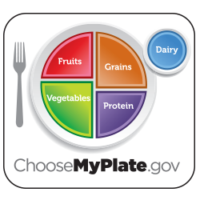
All adults need the same amount of food from the Protein Foods Group.
True
False

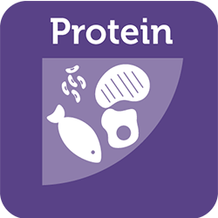
Protein Foods can contribute to sodium intake.
True
False

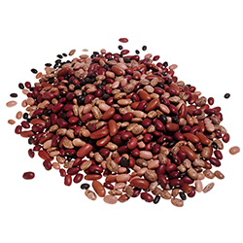
What food group are beans and peas counted in?
Vegetable Group
Protein Foods Group
Both
Neither

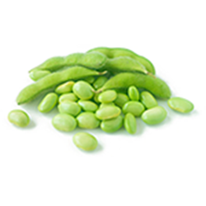
Which food is a vegetarian choice in the Protein Foods Group?
Hummus (made with chick peas)
Sesame seeds
Peanut butter
Black bean veggie burgers
All of the above

Nuts and seeds are good sources of what?
Protein
Dietary fiber
Minerals
Vitamin E
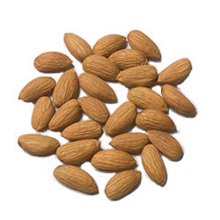
All of the above

What are these?
Pistachios
Almonds
Peanuts
Hazelnuts

Foods in the Protein Foods Group provide protein, but which of these foods from that group is also a source of calcium?
Peas
Sardines
Chicken
Ham

Eat seafood in place of meat or poultry twice a week.
True
False

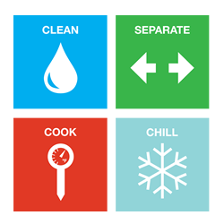
Should you wash or rinse raw meat or poultry before you cook it?
Yes
No

